TOWN OF ARROWSIC
340 ARROWSIC RD.
ARROWSIC, ME 04530
__________

TEL. 207- 4434608
FAX 207- 442-9082

October 31, 2025

Dear Mr. Rooney,

Thank you for the opportunity to comment on your preliminary plans for the reconstruction of two segments of Route 127 in Arrowsic [Arrowsic, Highway Reconstruction to Route 127 Including Large Culverts (#46976 and #270179), WIN 025663.00]. This project has the potential to significantly improve public safety and support local businesses in Arrowsic and Georgetown if the following is included in your plan.

- The plan should include storm surge predictions/models at these two sites to determine culvert size/road height. The current infrastructure considerations, as described by MaineDOT do not include storm surge in the predictions of sea level rise impacts (e.g. only uses 3.9 feet by 2100). These crossings cut off more than 1,500 residents from leaving the islands of Georgetown and Arrowsic, leaving these residents with no access to critical facilities like hospitals and gas stations. The Maine Climate Council clearly recommends that higher sea level rise scenarios are appropriate for projects focused on critical infrastructure, and this location is crucial to public safety of residents in two towns and for economic activity. Arrowsic's Climate Action Plan also supports including storm surge predictions for culvert replacements.

- Along with making the road safer for people, the importance of having the new infrastructure support the health of the tidal marshes both now and with sea level rise at 2100, is important for the community and region. The proposed culvert width at each site is concerning due to the fact that it appears much smaller than the width of the tidal creeks spanned by each culvert. Best practices for road crossing design encourage culvert widths larger than the channel width. Tidal sites, which are subject to even more dynamic environmental conditions and greater uncertainty, require at least the same degree of channel-spanning culvert width as their non-tidal counterparts, and frequently more, with hydrologic and hydraulic modeling an important part of appropriately sizing crossings. The proposed culvert widths do not acknowledge that.

Also, we request that MaineDOT include additional provisions for community involvement as stakeholders with meaningful opportunities for input in the design process. This should include opportunities for a discussion of all comments provided and how you will include these as the plan moves forward.

Sincerely,
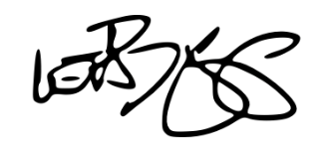
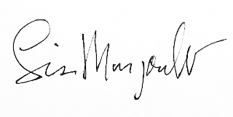

Walter Briggs
Arrowsic First Selectman
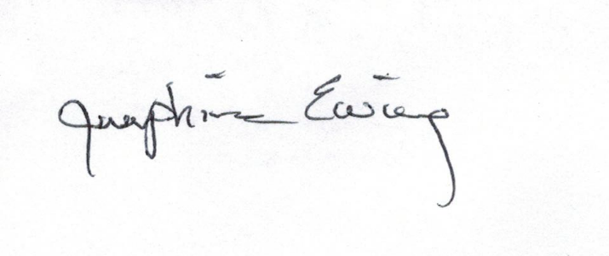

Josephine Ewing
Arrowsic Conservation Commission - Chair

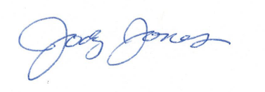
Jody Jones
Arrowsic Resilience Committee – Chair

Lisa Margonelli
Arrowsic Shellfish Conservation Cmte. – Chair

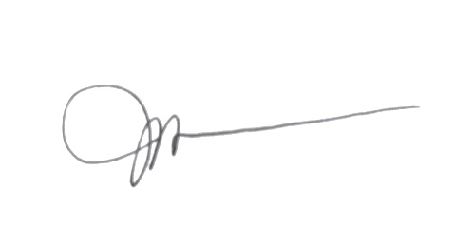
Jessica Weller
Georgetown Conservation Commission - Chair

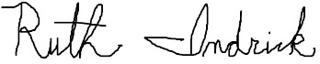
Ruth Indrick
Kennebec Estuary Land Trust – Project Manager

