Arrowsic Conservation Commission Minutes
March 17, 2026, Hybrid Meeting

Present: Phine Ewing (Chair), Clarke Cooper, Jesse MacMahon, Karen Robbins, Paul Schlein (remote), Keith Salcines (public)

- After a brief delay due to “technical difficulties”, the meeting was called to order at 5:40PM.
- The Commission had a meet and greet with Keith Salcines. He has volunteered to fill the empty position on the Commission. It was unanimously agreed to recommend the Select Board appoint Keith to the Conservation Commission starting in April.
- The minutes of the February 17, 2026, meeting were unanimously approved as presented with much gratitude for the detailed reporting.
- No mail has been received this month.
- The Annual Report was accepted as amended. Phine will send it on to Irene.
- After much discussion it was decided decide to ask for $1000.00 for the 2026/27 budget cycle. Per a discussion with the Select Board, mailing of water samples will be included in this year’s Budget. The budget breakdown break down is: $525 for water quality assays, $175 for mailing of samples to the lab; $200 for outreach materials needed for the Pesticide Citizen Education Initiative; $100 for annual maintenance activities at the Sewall Pond Conservation Area.
- Route 127 Culvert Projects update: The letter to MDOT has been written, signed and mailed. A grant application for $100,000 has been submitted to the Maine Coastal Program for additional modeling of the MDOT Culvert Projects. The grant was written by the Resilience Committee.
- A brief summary of the Fish Commission’s Sewall Creek Project was given. They are currently looking for funding to complete the engineering design so the project can be “dig ready” when additional funding to make the identified improvements becomes available.
- Looking at the calendar, recycling pickup schedule and tide charts it was determined Saturday, April 25th, 9:30AM would be the preferred date and time. Phine will let the Nadine and the Recycling Committee know.
- The weather is changing and we are in “big night” season. Based on past experience it was decided to remind people to be aware especially on those “dark and rainy nights” of all the amphibians, mammals and reptiles we share the roads with. Jesse will write the announcement for next Monday’s Arrowsic News.
- Natures Notes: Phine found a spotted salamander dead on Indian Rest Rd. and her snow drops were blooming on March 10th. Clarke noticed this year the extent of the river ice was similar to 15 years ago only much thinner. He is attributing that to the warmer waters in the Gulf of Maine. He also saw a very white ermine. Jesse saw a flock of Bohemian waxwings while on a walk, excitedly she returned the next day with her camera, alas they were gone. Paul, on an island in the Bahamas, shared that the birds on the island create a cacophony of sounds. He is particularly fond of the Bahama mockingbird’s endlessly loquacious calling. There are thick-billed vireos and the flamingoes are increasing in numbers compared to the last few years. He also told us that lignum vitea is the National Tree. It has lavender- colored blooms and is ubiquitous (see photo).
- The next meeting is April 21, 2026, 5:30PM at the Arrowsic Town Hall.
- The meeting adjourned at 6:50PM.

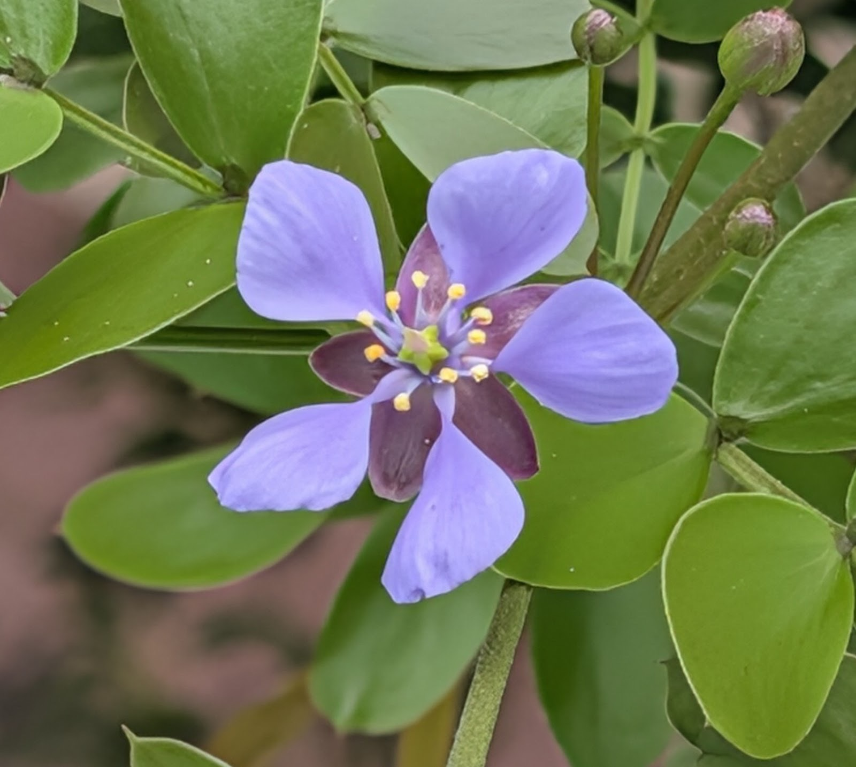

Very respectfully,
Karen Robbins, acting Secretary

